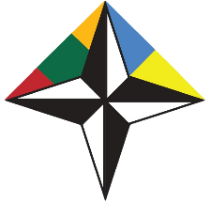

EMBASSY OF THE REPUBLIC OF LITHUANIA IN UKRAINE
NATO CONTACT POINT EMBASSY 2015-2018

Euro-Atlantic Youth Security Forum

Cherkasy, Ukraine • 25-27 April, 2018
Venue: Bohdan Khmelnytsky National University of Cherkasy

DRAFT PROGRAMME

25 April, Wednesday
Arrival of the participants
19:30 Ice-breaker event / dinner

26 April, Thursday
09:00-09:30 Registration, morning coffee
09:30-09:45 Opening of the Forum
09:45-13:00 Session 1: “Building the Euro-Atlantic Security”

Topics:
- Changing global security environment. What are the challenges and how to approach them?
- Hybrid warfare
- What is NATO and what is its purpose in the contemporary world?
- NATO as a military Alliance

13.00-14.00 Lunch break
14:00-17:00 Session 2: “NATO – Ukraine Distinctive partnership”

Topics:
- Ukraine’s role in the Euroatlantic security
- 20 years of NATO – Ukraine Distinctive partnership. NATO’s support for Ukraine.
- How does NATO work? Main formats, decision making, rules of work in NATO. Setting the ground for tomorrow’s simulation.

18:00 Dinner

27 April, Friday
09:30-11:30 Simulation “How does NATO work: meeting of the North Atlantic Council”

11.30-12.45 Lunch
12:45-14:15 Simulation 2: “NATO-Ukraine Commission meeting”

14:15 Conclusions of the Forum

